KLE Society's

KLE Technological University



**Computer Networks-2**

**Hotel Management Case Study**

**Under the guidance of**

**Dr. Vijet Kotagi**

**Submitted By**

Raghavendra M K 01fe20bcs133

Akash V Dalawayi 01fe20bcs154

Om Vishnudas Prabhu 01fe20bcs157

Gurutej R Abbigeri 01fe20bcs159

School of Computer Science and Engineering,

Vidyangar, Hubballi – 580031,

Academic year 2022-23

**List of Chapters**

| **Chapter**  **No** | **Chapter name** | **Page No** |
| --- | --- | --- |
| 1 | Topology | 3-4 |
| 2 | Ip Scheme | 5-7 |
| 3 | Protocols | 8-17 |
| 4 | Financial Analysis | 18 |

**1.Topology**

The Case Study Hotel Management.

The hotel consists of ,

* 3 buildings.
* Each building has 3 floors.
* Each floor has 20 rooms and 5 wifi access points.
* Each room has 1 Ethernet port.

**1.1 Diagram representing the topology.**

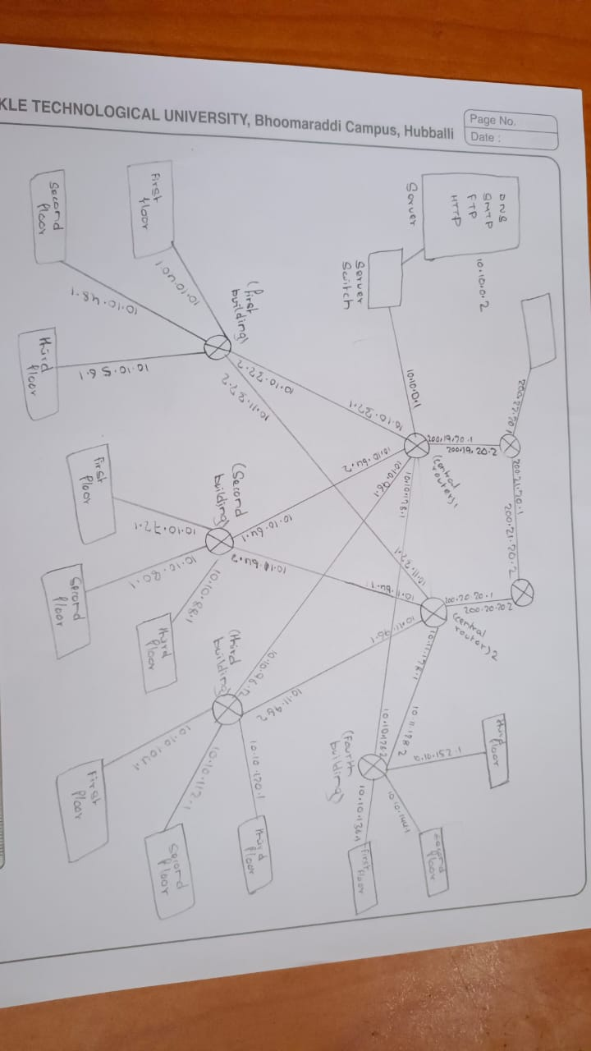

**1.2 Image representing implementation of topology in Cisco Packet Tracer.**

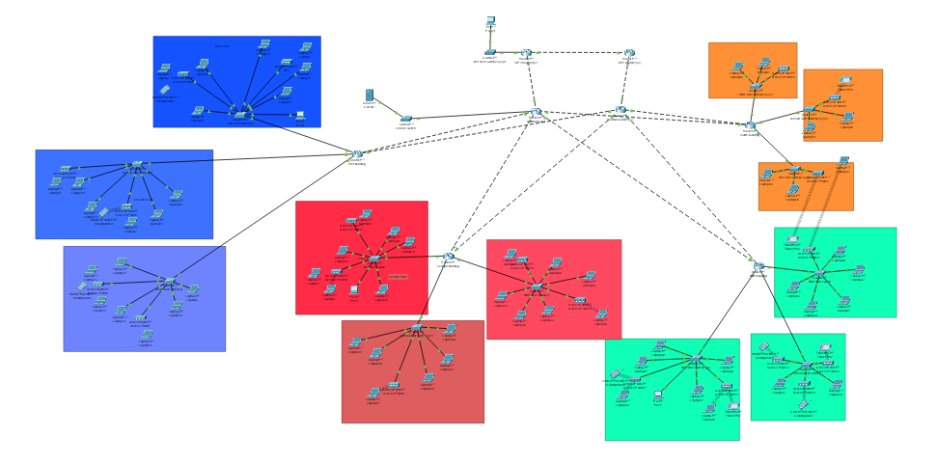

**2.Ip Scheme**

**Central router :**

**CIDR: 19**

**Possible network: 16**

| **Network** | **Number of host** | **Net mask** |
| --- | --- | --- |
| **10.10.0.0** | **8191** | **255.255.224.0** |
| **10.10.32.0** | **8191** | **255.255.224.0** |
| **10.10.64.0** | **8191** | **255.255.224.0** |
| **10.10.96.0** | **8191** | **255.255.224.0** |
| **10.10.128.0** | **8191** | **255.255.224.0** |

**Central router 2 :**

**CIDR: 19**

**Possible network: 16**

| **Network** | **Number of host** | **Net mask** |
| --- | --- | --- |
| **10.11.32.0** | **8191** | **255.255.224.0** |
| **10.11.64.0** | **8191** | **255.255.224.0** |
| **10.11.96.0** | **8191** | **255.255.224.0** |
| **10.11.128.0** | **8191** | **255.255.224.0** |

**First building:**

**CIDR: 21**

**Possible network: 4**

| **Network** | **Number of host** | **Net mask** |
| --- | --- | --- |
| **10.10.40.0** | **2047** | **255.255.248.0** |
| **10.10.48.0** | **2047** | **255.255.248.0** |
| **10.10.56.0** | **2047** | **255.255.248.0** |

**Second building:**

**CIDR: 21**

**Possible network: 4**

| **Network** | **Number of host** | **Net mask** |
| --- | --- | --- |
| **10.10.72.0** | **2047** | **255.255.248.0** |
| **10.10.80.0** | **2047** | **255.255.248.0** |
| **10.10.88.0** | **2047** | **255.255.248.0** |

**Third building:**

**CIDR: 21**

**Possible network: 4**

| **Network** | **Number of host** | **Net mask** |
| --- | --- | --- |
| **10.10.104.0** | **2047** | **255.255.248.0** |
| **10.10.112.0** | **2047** | **255.255.248.0** |
| **10.10.120.0** | **2047** | **255.255.248.0** |

**Fourth building:**

**CIDR: 21**

**Possible network: 4**

| **Network** | **Number of host** | **Net mask** |
| --- | --- | --- |
| **10.10.136.0** | **2047** | **255.255.248.0** |
| **10.10.144.0** | **2047** | **255.255.248.0** |
| **10.10.152.0** | **2047** | **255.255.248.0** |

**3.Protocols**

The protocols implemented in the topology are,

**1)HTTP**

The Hypertext Transfer Protocol (HTTP) is the foundation of data communication on the World Wide Web (WWW) and is used to transmit and receive data over the internet.

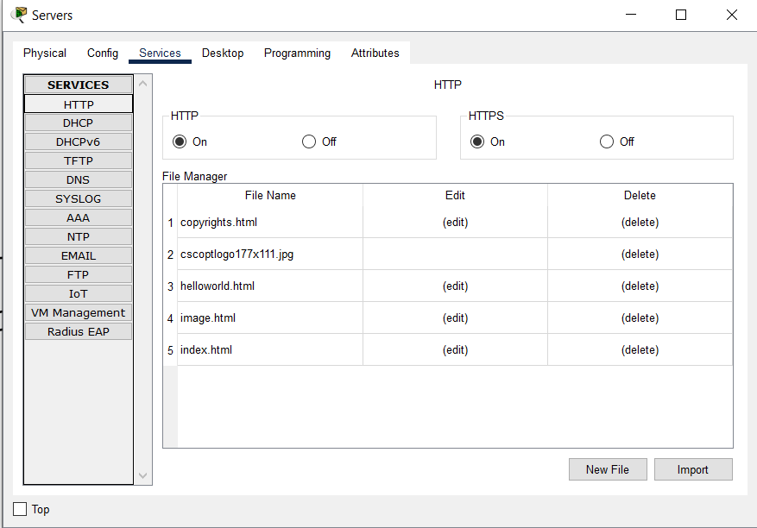

**2)FTP**

The File Transfer Protocol (FTP) is a standard network protocol used to transfer files between computers on the internet or a network

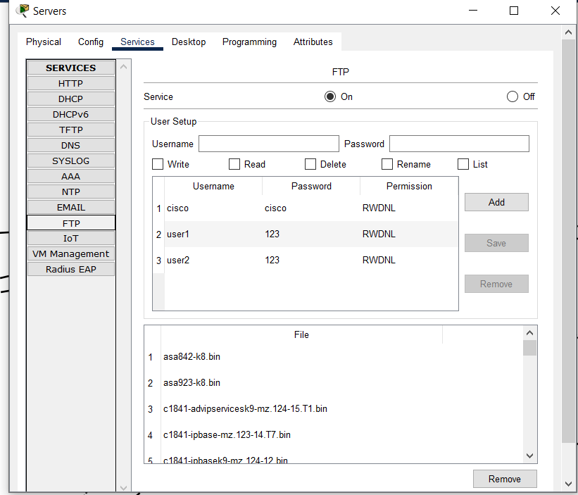

**3)DHCP**

Dynamic host configuration protocol used to assign ip dynamically to physical devices.

**en** //This enters privileged EXEC mode on the router.

**conf t** //This enters global configuration mode on the router.

**ip dhcp pool firstfloor** //This creates a new DHCP pool named "firstfloor" on the router.

**network 10.10.40.0 255.255.248.0** //This specifies the network address and subnet mask of the DHCP pool.

**default-router 10.10.40.1** //This sets the default gateway for clients using this DHCP pool to the IP address 10.10.40.1.

**ip dhcp excluded-address 10.10.40.1** //This specifies that the IP address 10.10.40.1 should not be assigned by the DHCP server. This address is reserved for the default gateway that was set in the previous command.

**ip name-server 10.10.0.2** //This sets the DNS server for clients using this DHCP pool to the IP address 10.10.0.2.

**do write memory** //Save the current configuration.

**ip dhcp pool secondfloor**

**network 10.10.48.0 255.255.248.0**

**default-router 10.10.48.1**

**ip dhcp excluded-address 10.10.48.1**

**ip name-server 10.10.0.2**

**do write memory**

**ip dhcp pool thirdfloor**

**network 10.10.56.0 255.255.248.0**

**default-router 10.10.56.1**

**ip dhcp excluded-address 10.10.56.1**

**ip name-server 10.10.0.2**

**do write memory**

**en**

**conf t**

**ip dhcp pool firstfloor**

**network 10.10.136.0 255.255.248.0**

**default-router 10.10.136.1**

**ip dhcp excluded-address 10.10.136.1**

**ip name-server 10.10.0.2**

**do write memory**

**ip dhcp pool secondfloor**

**network 10.10.144.0 255.255.248.0**

**default-router 10.10.144.1**

**ip dhcp excluded-address 10.10.144.1**

**ip name-server 10.10.0.2**

**do write memory**

**ip dhcp pool thirdfloor**

**network 10.10.152.0 255.255.248.0**

**default-router 10.10.152.1**

**ip dhcp excluded-address 10.10.152.1**

**ip name-server 10.10.0.2**

**do write memory**

**4)DNS**

The Domain Name System (DNS) is a hierarchical decentralized naming system for computers, services, or any resource connected to the Internet or a private network.

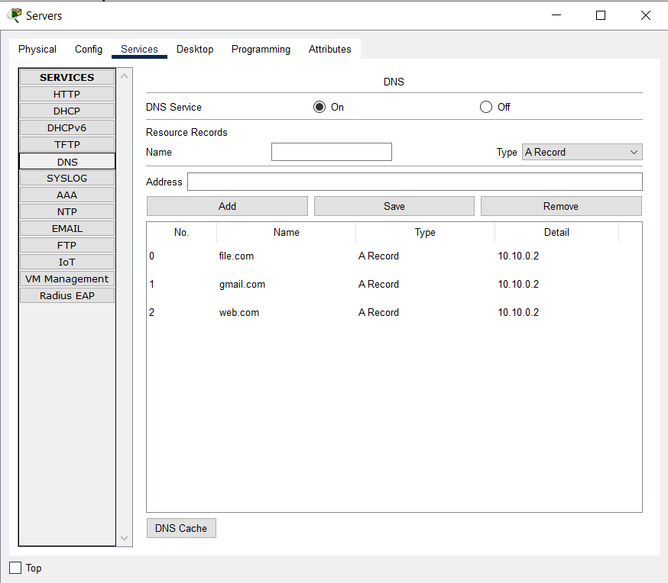

**5)SMTP**

The Simple Mail Transfer Protocol (SMTP) is a standard protocol used for sending and receiving email messages between servers and clients.

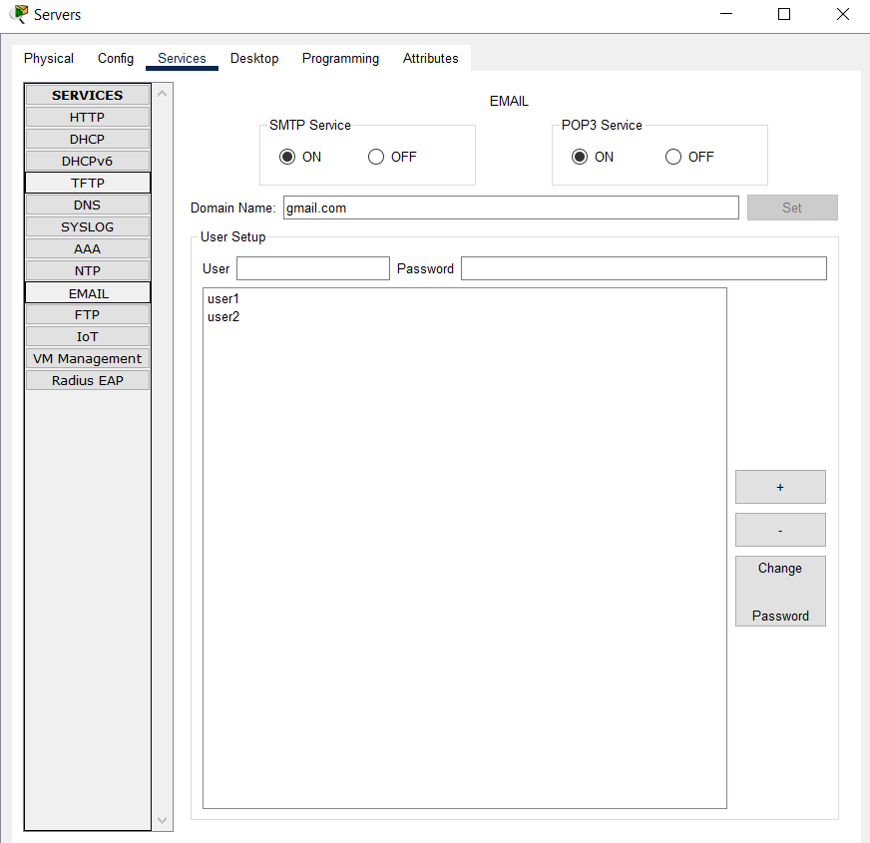

**6)RIP**

The Routing Information Protocol (RIP) is a distance-vector routing protocol used in local area networks (LANs) and wide area networks (WANs) to determine the best path for data to travel between two nodes or devices.

Example of code snippet to enable RIP in first building router:

**router rip**

**version 2**

**network 10.10.40.0**

**network 10.10.32.0**

**network 10.10.48.0**

**network 10.10.56.0**

**network 10.11.32.0**

**do write memory**

The **router rip** command enables RIP routing on the router. The **version 2** command specifies that RIP version 2 should be used. This version includes support for variable-length subnet masks (VLSM) and multicast updates.

The **network** commands specify the network addresses that should be advertised using RIP. In this configuration, five networks are being advertised: 10.10.40.0, 10.10.32.0, 10.10.48.0, 10.10.56.0, and 10.11.32.0.

The **do write memory** command saves the current configuration to non-volatile memory, so that it will be retained after a reboot.

**7) NAT**

In Dynamic NAT, IP addresses are dynamically mapped to each other on a one-to-one basis as per the needs. It establishes a mapping between an Inside Local IP address and a pool of Global IP addresses.

Central routers were NAT enabled routers

commands:

**en**

**conf t**

Configure the router’s outside interface

**int f0/6**

**ip nat outside**

**exit**

Configure the router’s inside interface

**int f0/0**

**ip nat inside**

**exit**

**int f0/1**

**ip nat inside**

**exit**

**int f0/9**

**ip nat inside**

**exit**

**int f0/8**

**ip nat inside**

**exit**

Configure the pool of global IP addresses

**ip nat pool pool1 72.10.11.2 72.10.11.6 netmask 255.255.255.0**

Configure access-list that has list of inside address that will be translated

**access-list 1 permit 10.10.0.0 0.0.255.255**

Enable the NAT

**ip nat inside source list 1 pool pool1**

x

**4.Financial Analysis**

| **SI.No** | **Equipment** | **per unit cost** | **quantity** | **cost** |
| --- | --- | --- | --- | --- |
| **1** | **Router,8 ports** | **3,30,739Rs** | **6** | **19,84,434/-** |
| **2** | **1Gbps ethernet cable** | **40Rs /m** | **570m** | **22,800/-** |
| **3** | **100Mbps ethernet cable** | **25Rs/m** | **19020m** | **4,75,500/-** |
| **4** | **Dell R730xd server** | **1,87,950Rs** | **1** | **1,87,950/-** |
| **5** | **Switch,48 ports** | **1,10,000Rs** | **13** | **14,30,000/-** |
| **6** | **Access point** | **20,351Rs** | **60** | **12,21,060/-** |
| **Total** | | | | **53,21,744/-** |

**Service charge 12% =6,38,609/-**

**Total cost=59,60,353/-**